**SOFTWARE ENGINEERING LAB TASK 2**

**04-12-2024**

**HU22CSEN0100287**

**SAI GANESH ESWARAPRASAD**

Write any program is google colab using hard coding variables, keyboard input, read from a file single input and read from a file multiple set of inputs and save all the versions, debug and fix any errors, push all the versions into your git hub account.

**Steps:**

**1. Hardcoding Variables**: Demonstrate by using predefined

values.

**2. Keyboard Input:** Use Python's input() to accept data from the

user.

**3. Read From File (Single Input)**: Read a single input from a

file.

**4. Read From File (Multiple Inputs)**: Read multiple inputs

from a file and process them.

**5. Save All Versions:** Save each version of the program in

different cells/files.

**6. Debug and Fix Errors:** Handle errors like missing files,

incorrect input, etc.

**7. Push Versions to GitHub:** You can use git commands within

Colab (assuming the repository is already initialized).

1. **Set Up GitHub Repository**
2. 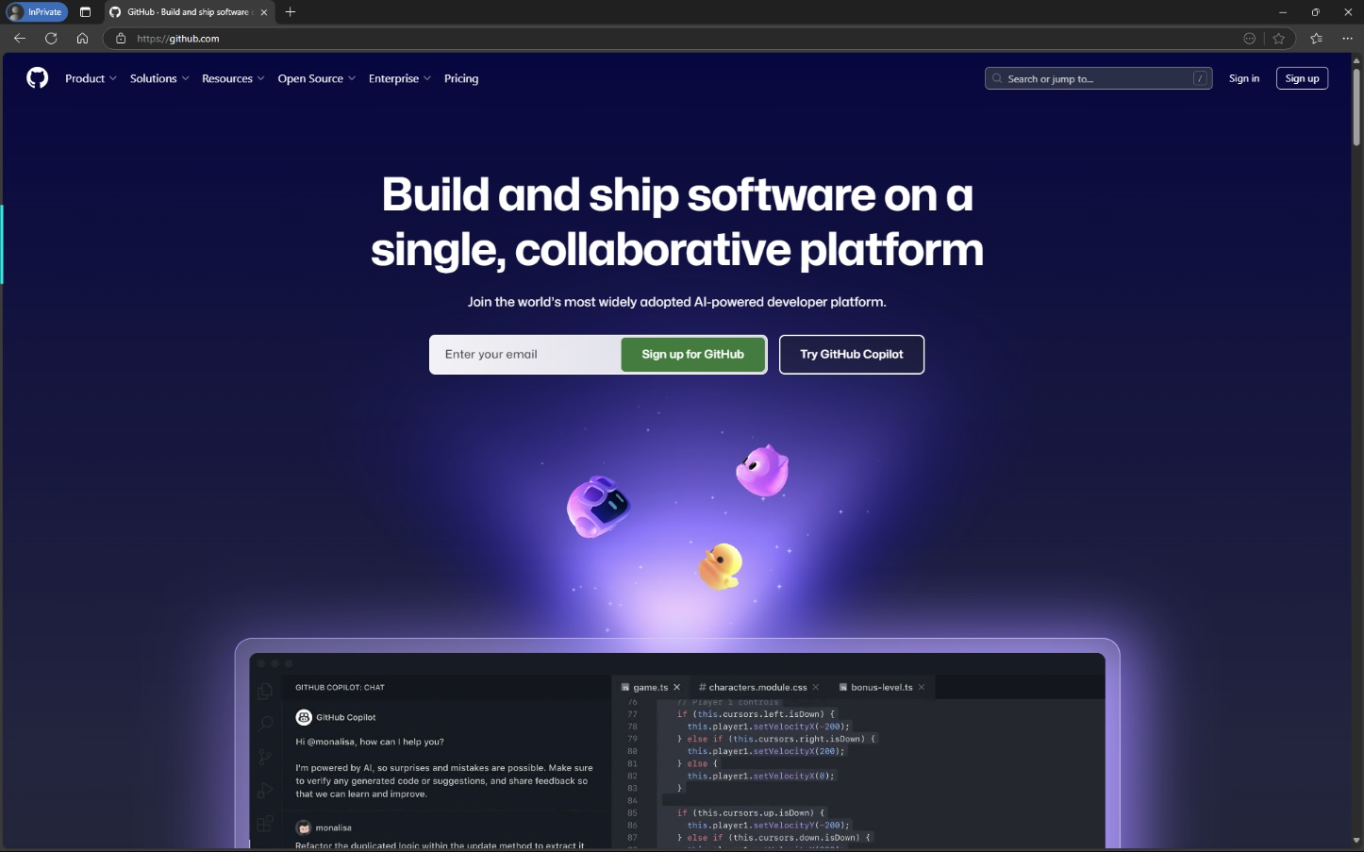Go to GitHub
3. 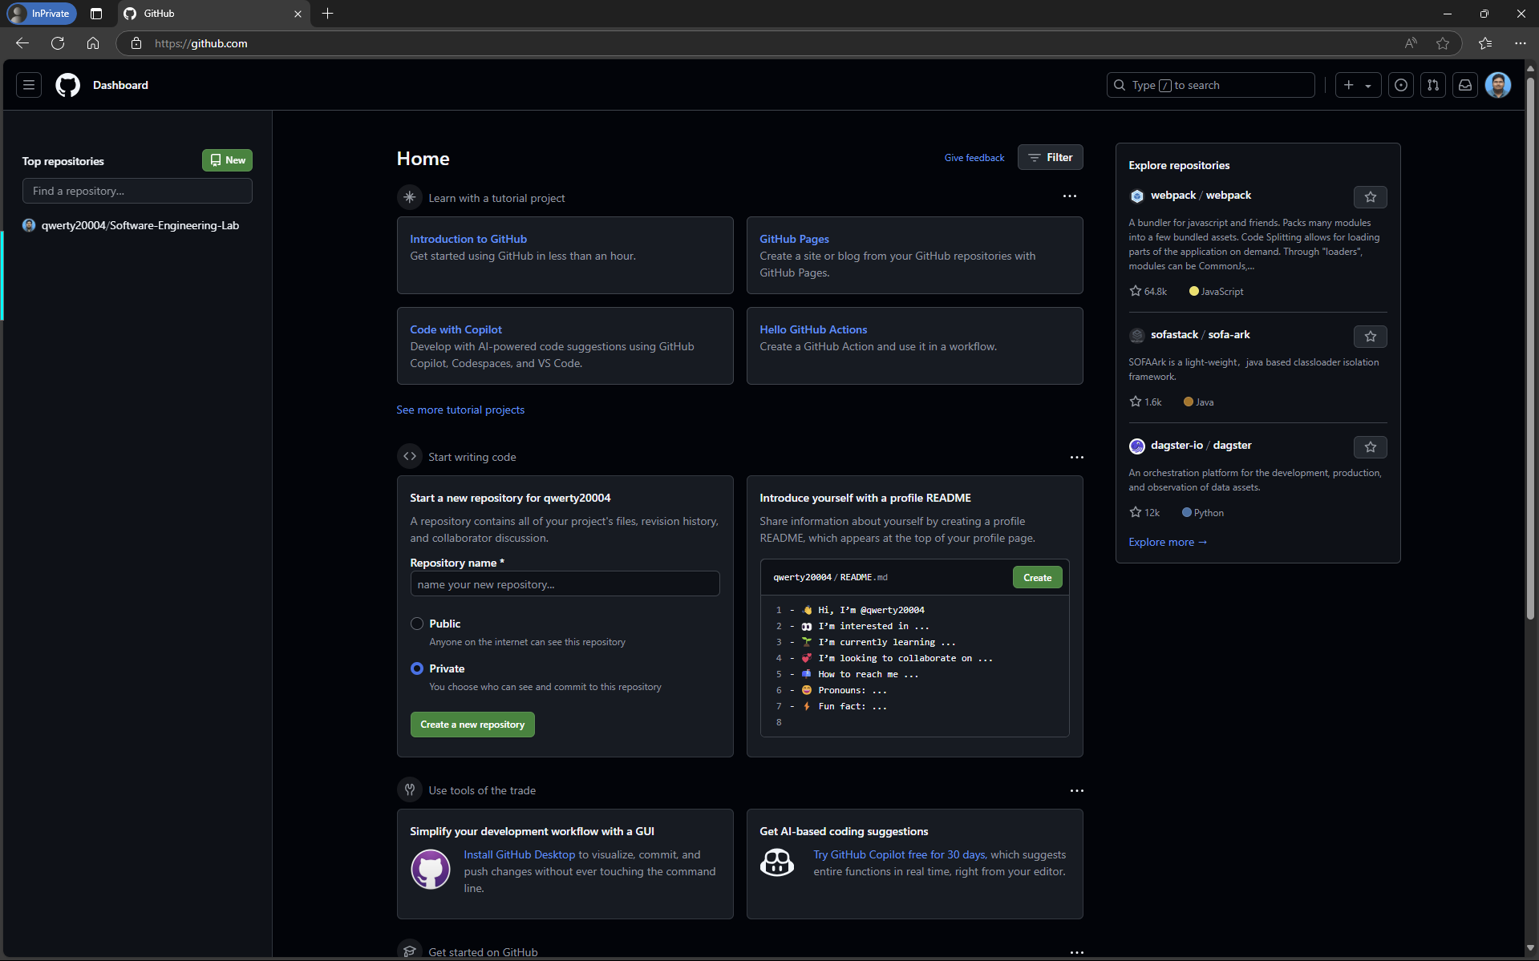 Log into your GitHub account.
4. Create a New Repository by clicking on “New” Button on left panel and fill necessary details

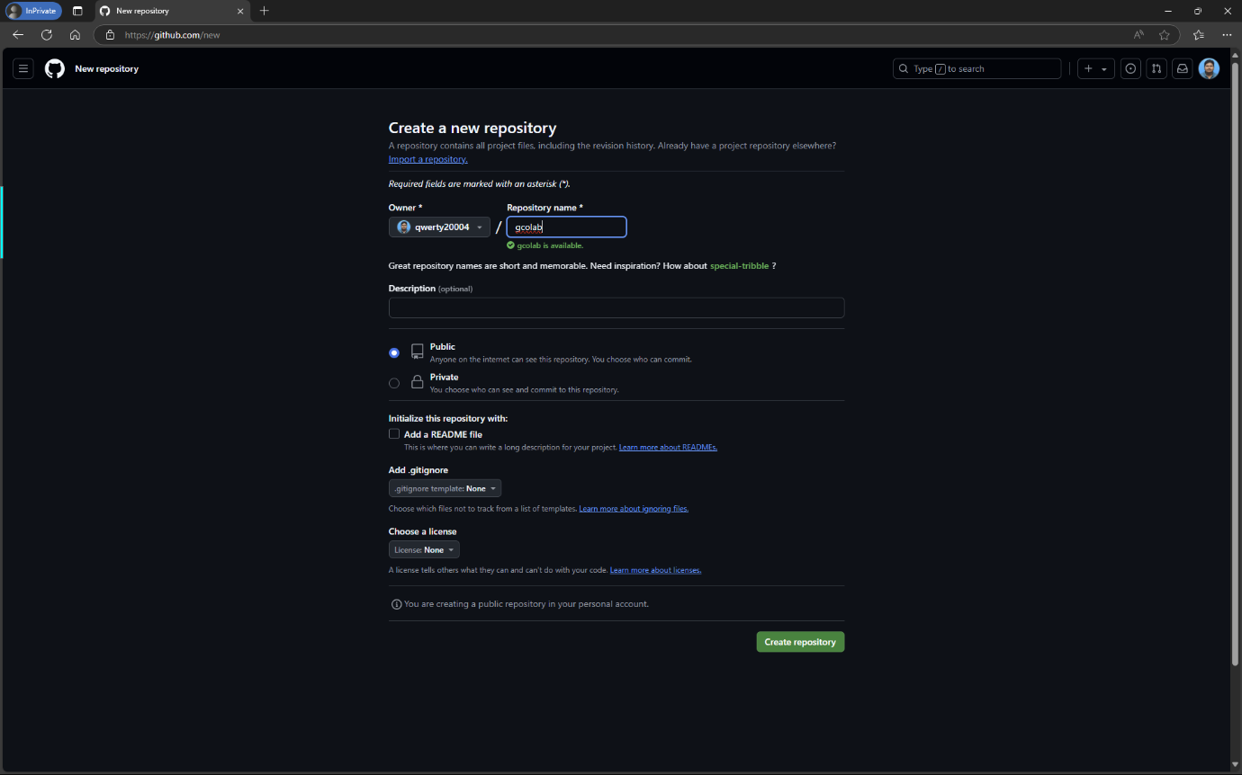Do **not** initialize the repository with a README.

1. 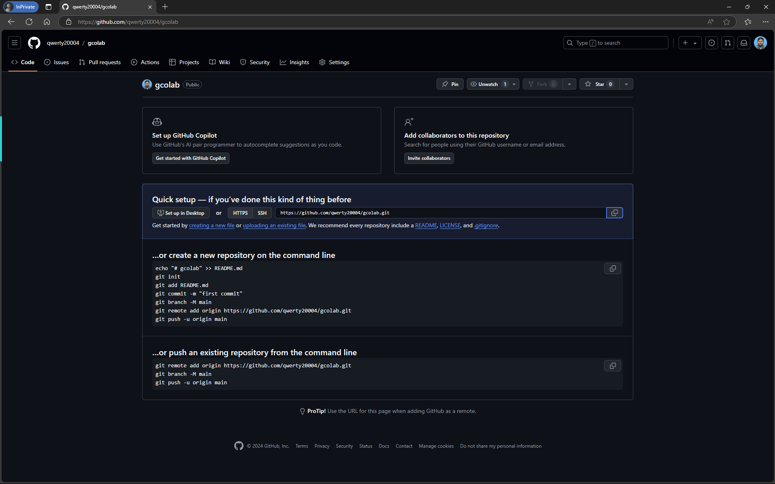Copy Repository URL
2. **Connect Google Colab to Google Drive**
3. 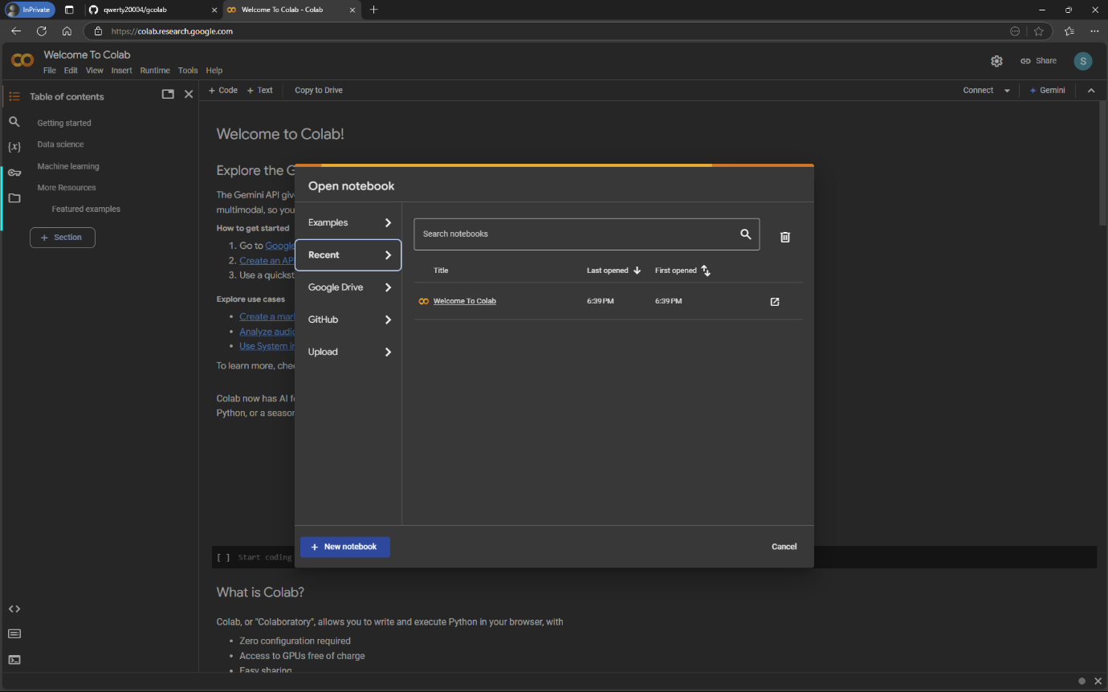Login to Google Colab using Google Account
4. 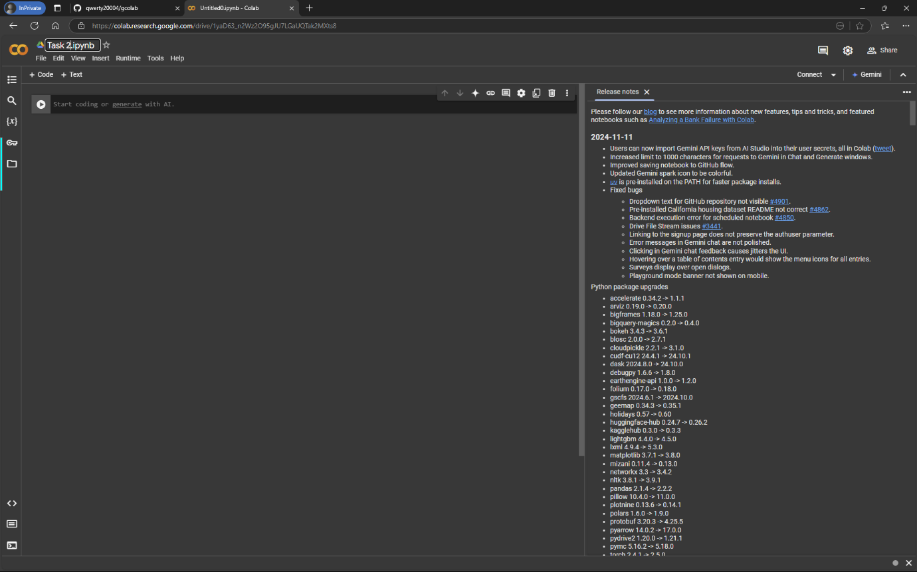Create New Notebook and rename Notebook name
5. 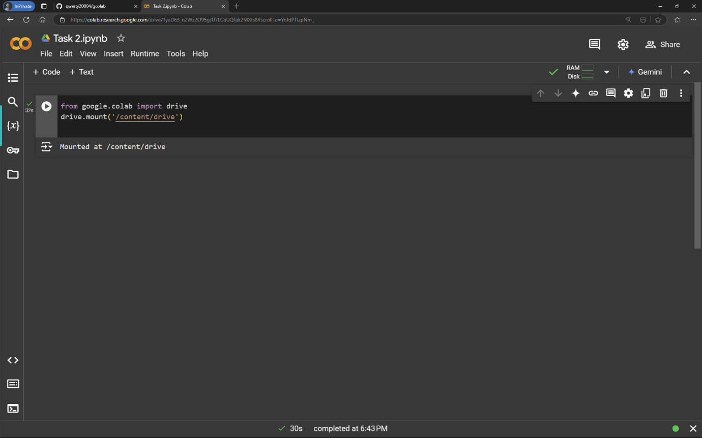Run the following code to mount your Google Drive
6. **Create the Program**
7. 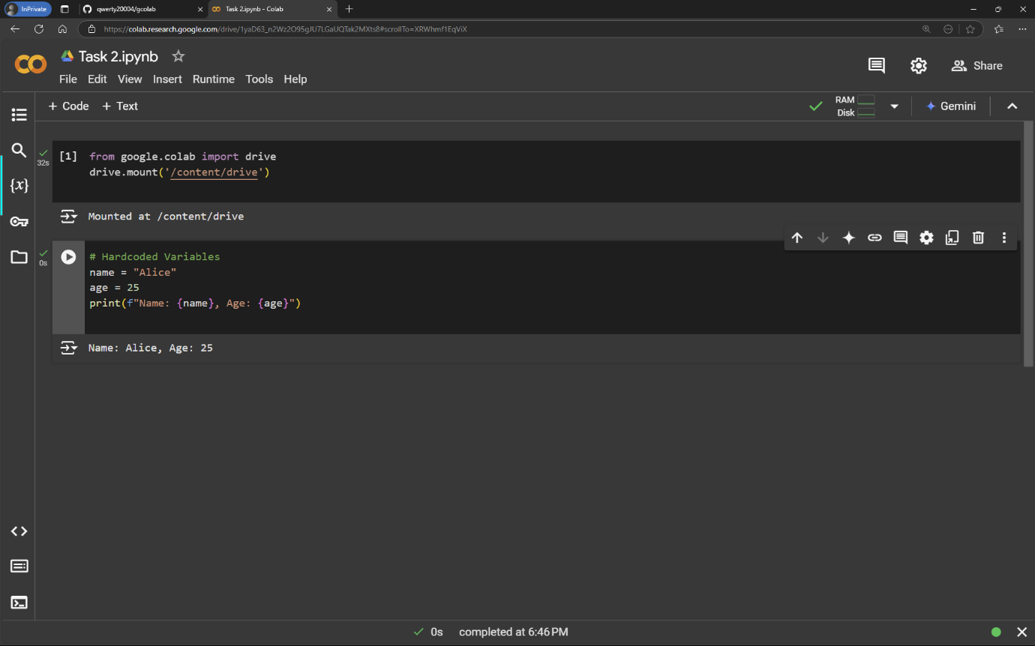Step 1: Hardcoding Variables (Click ‘+ Code’)
8. Step 2: Keyboard Input

Accept data using input() function

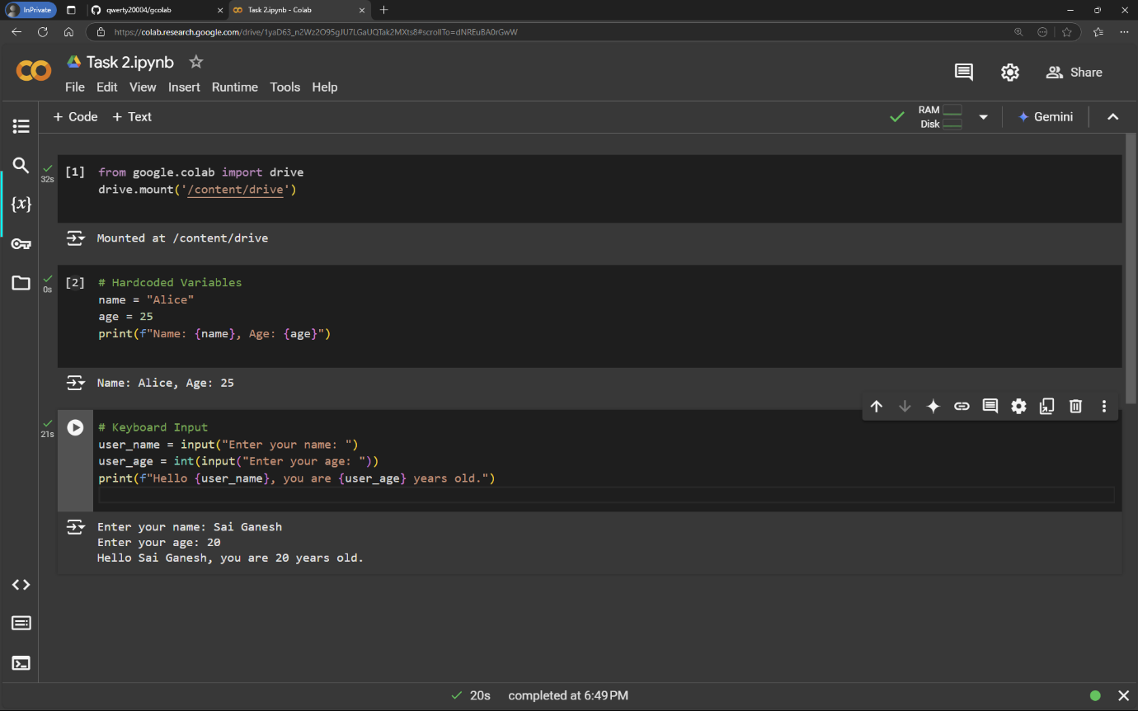

1. Step 3: Read From File (Single Input)

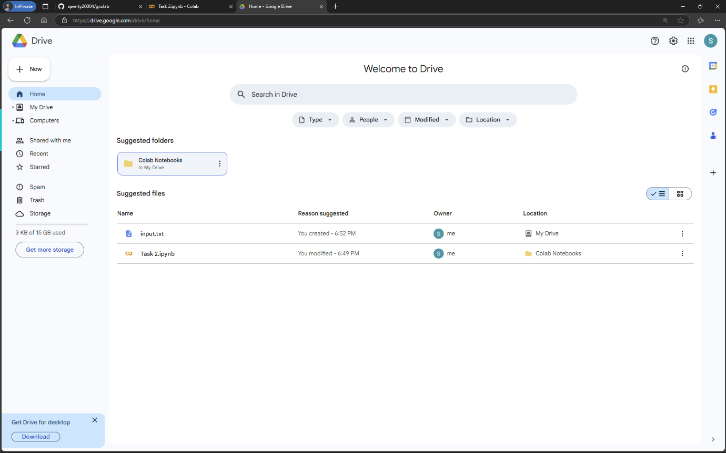Save a file (input.txt) in your Drive or upload it. Example content: Hello, World!.

1. 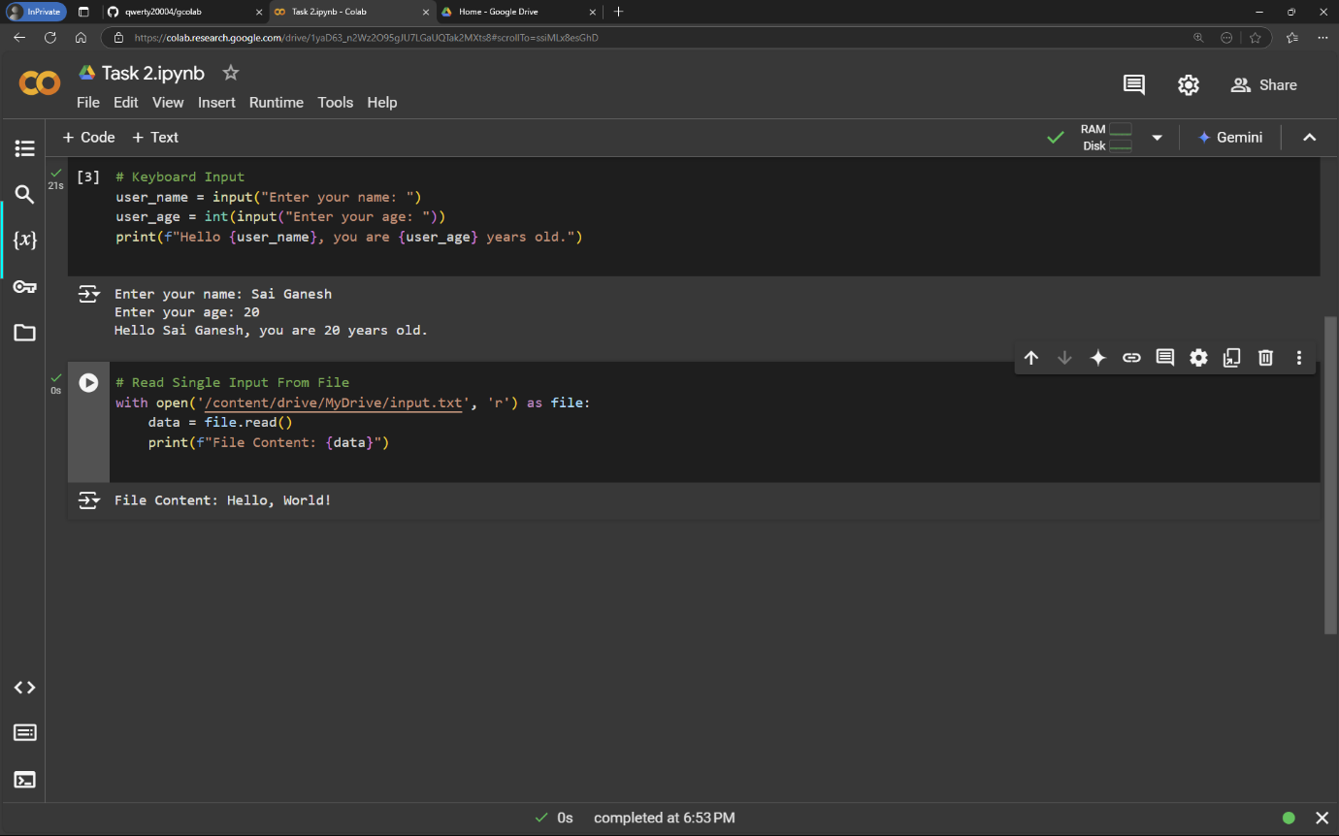Read From File (Multiple Inputs)

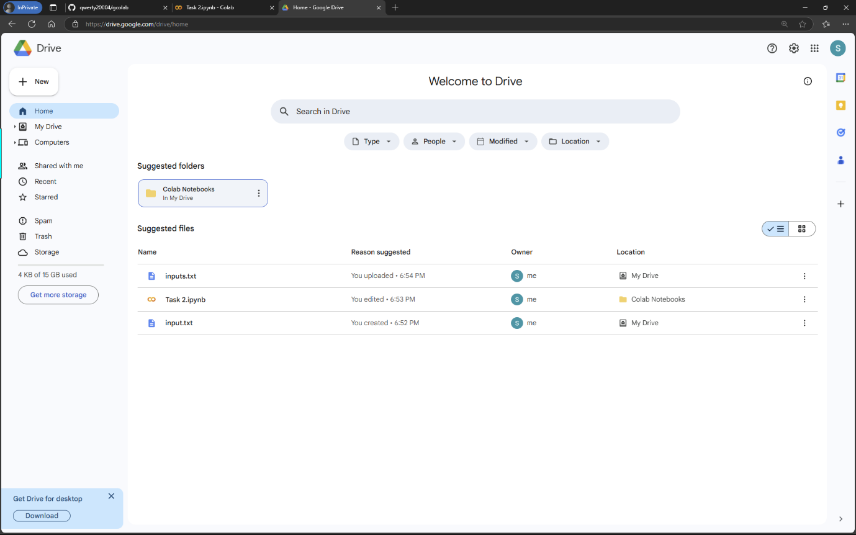Save a file (inputs.txt) in your Drive with multiple lines of data.

1. 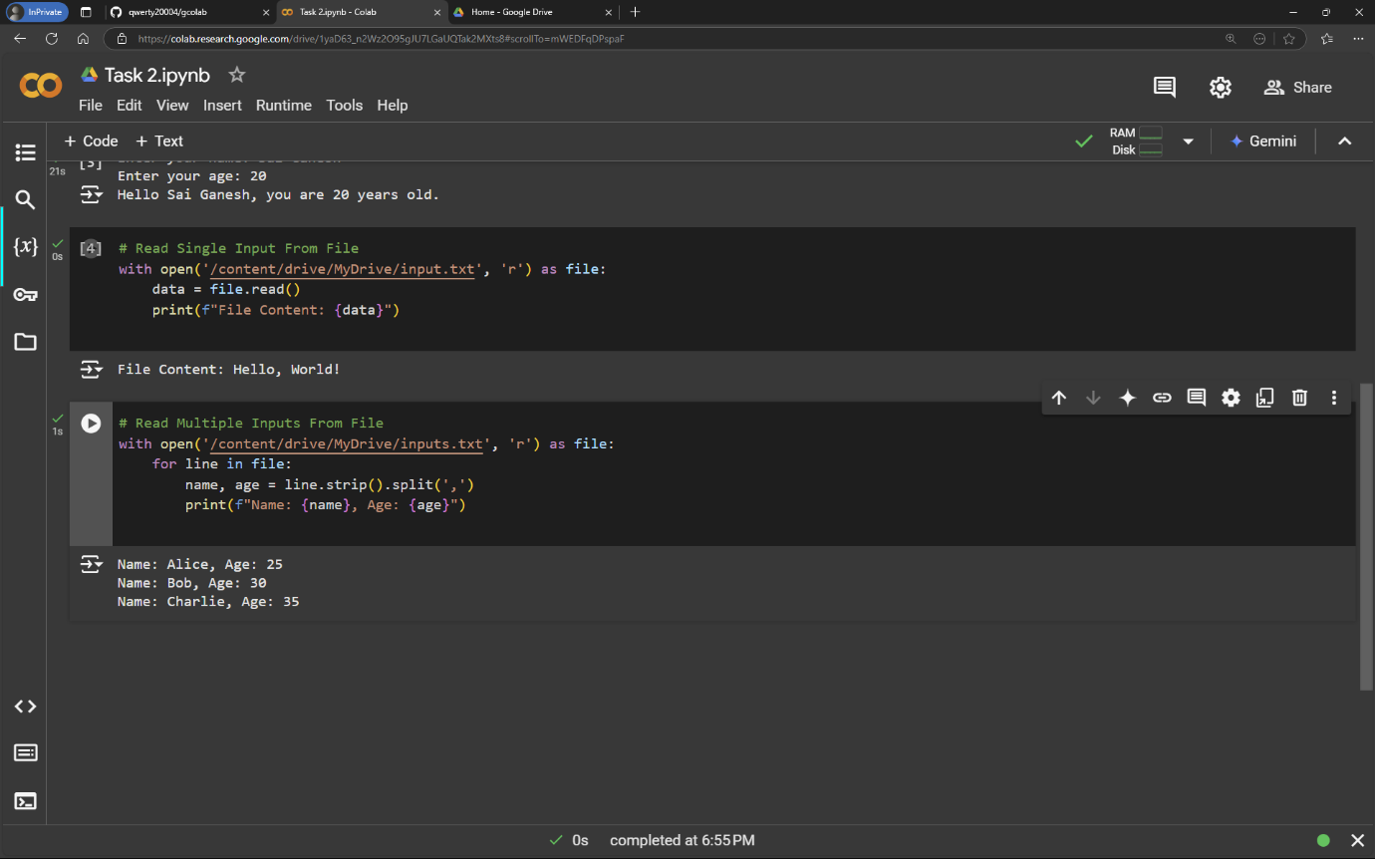Step 5: Save All Versions

Save different versions of the code by creating new cells for each variation in the notebook.

1. Step 6: Debug and Fix Errors

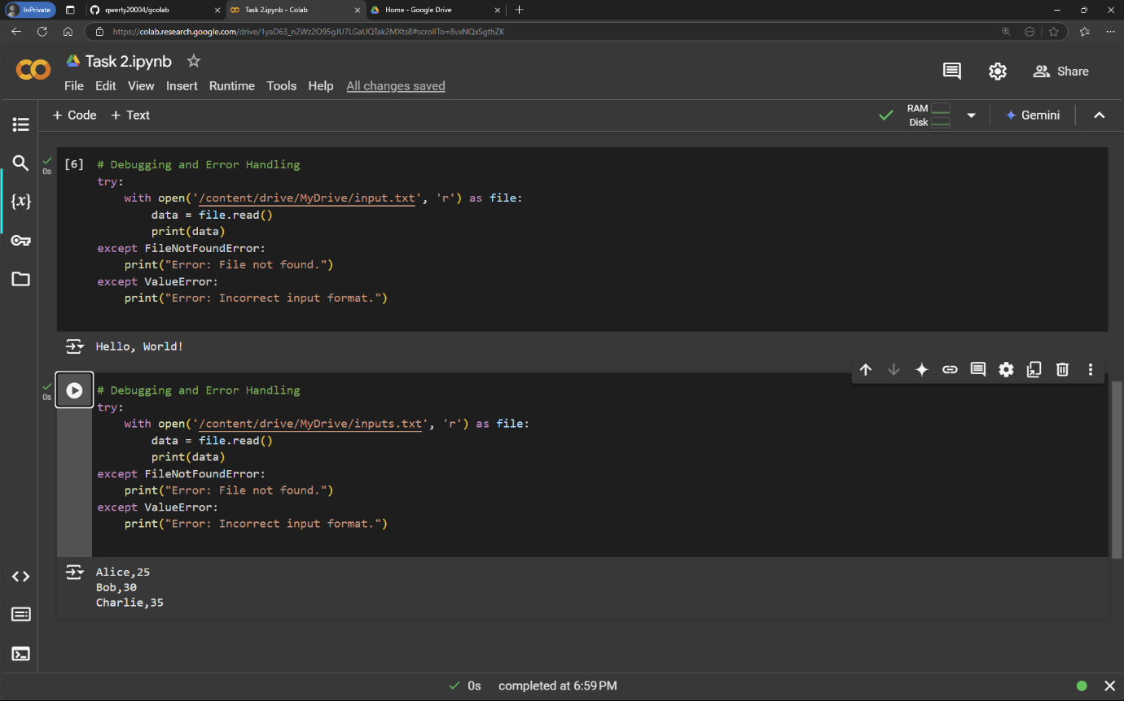Add error handling for missing files or incorrect inputs

1. **Push Versions to GitHub:**

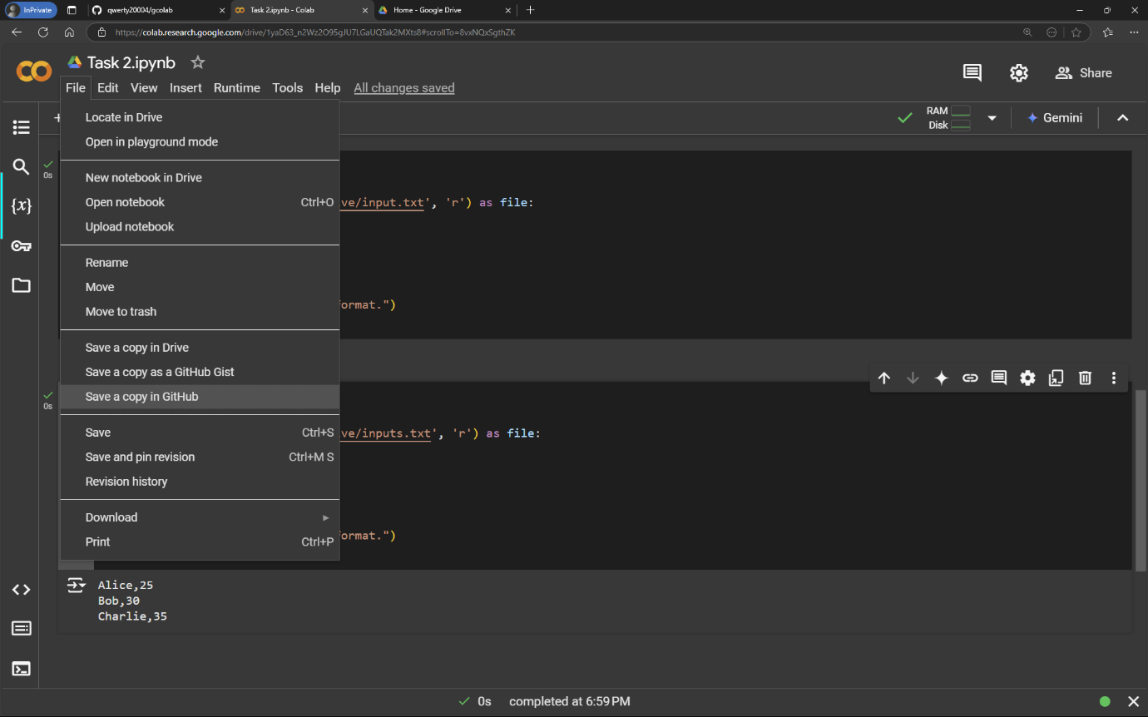Uses git commands within Colab to push changes.

